WEEK – 1 DATA COLLECTION AND PREPROCESSING
NOTE:- LINK OF EXCEL WORKBOOK IS AT THE LAST PAGE – 15 WHICH CONTAINS CLEAN DATA
For the week- 1 we have to do the following steps:-
1. Data Collection
2. Data Cleaning
3. Data Preprocessing

INTRODUCTION:-
The real question is What is Marketing analytics?
Marketing Analytics is the process of collecting and analyzing data from marketing campaigns to evaluate performance, understand customer behavior and optimize the profit to reach a quantitative goal.
Objective of this task:- It’s Objective is to create useful insights from data such that we can know where we have to focus on underperforming channels and main goal is to optimize the profit from marketing campaigns such that we can reach our goal.

STEP 1: DATA COLLECTION
Dataset Name:- Marketing Campaign Results
Source:- Maven Analytics
About the Data:- Marketing campaign data of 2,240 customers of Maven Marketing, including customer profiles, product preferences, channel performance, and campaign success.
Data Collection process how we download and merged the data in excel
1. Click On Download the Dataset:-

Image-1 (Downloading the Dataset)
2. Then Downloads > Marketing + Data It contains 2 Files
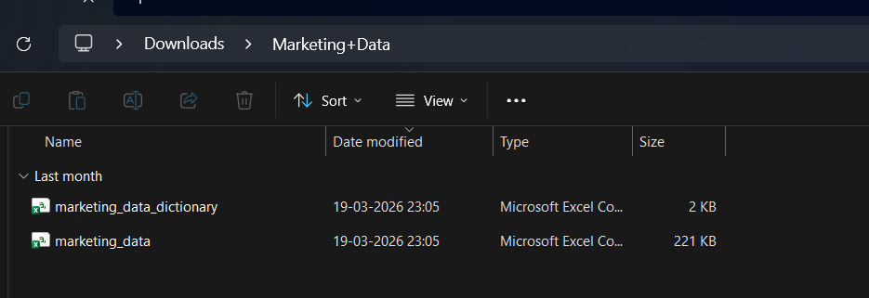
Image – 2(Extracting the Files)
3. Open the File in MS Excel It should look like this:-
File -> Open -> Select csv File
marketing_data :- contains the data about Marketing Campaigns.
The Data Contains 2240 columns
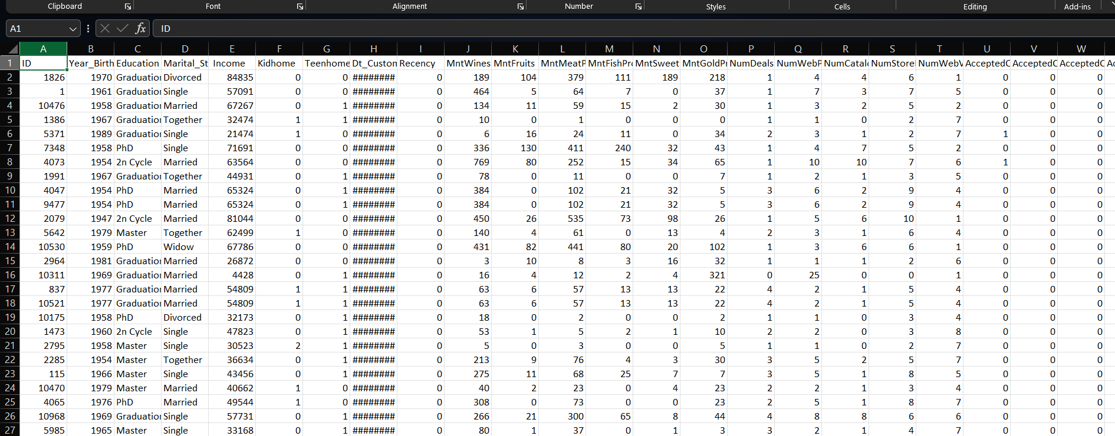
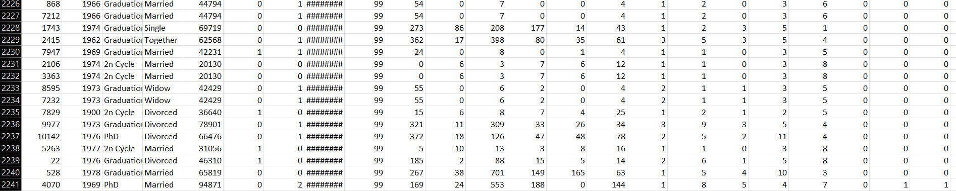
Image-3(Opening the Files in Microsoft Excel)
marketing_data_dictionary:- It contains the metadata of data.
Note:- A Metadata is Data about Data.
It contains the following columns that are useful to create insights the Types of Products and Campaign Performance are mainly the targeted columns.
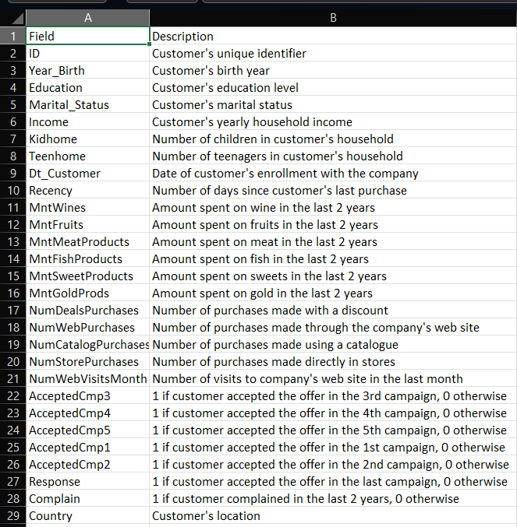
Image – 4(Metadata)

Since the dataset did not contain direct advertising metrics such as impressions, clicks and cost, these values are derived using logical assumption NumWebVisitsMonth is treated as Impressions , NumWebPurchases were treated as clicks and campaign Response is treated as conversions and cost is treated as NumWebPurchases.
Impressions:- NumWebVisitsMonth * 1000
Clicks:- NumWebPurchases
Conversions:- Response
Cost:- NumWebPurchases * 2
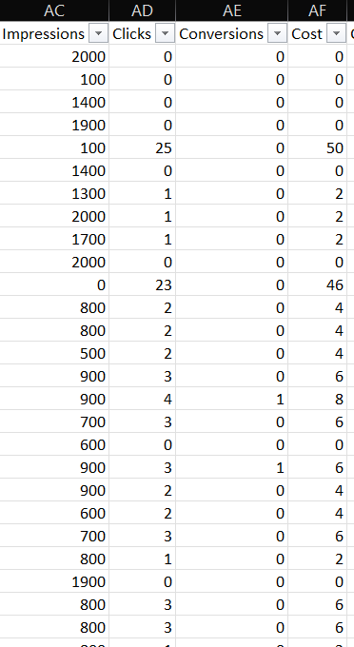
Image – 5(Impressions, Clicks,Conversions,Cost)

IMPORTING THE DATA IN SQL FROM EXCEL:-
Before Cleaning first we will import he data in SQL from excel
1. first we will create a database for me it is market database then right click it go to
Tasks -> Import Data
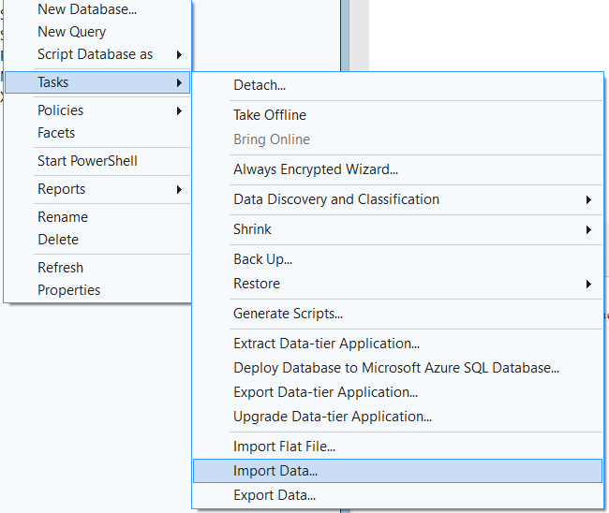
Image – 6(Import in SQL from excel)

Then it will open SQL Server Import and Export Wizard :-
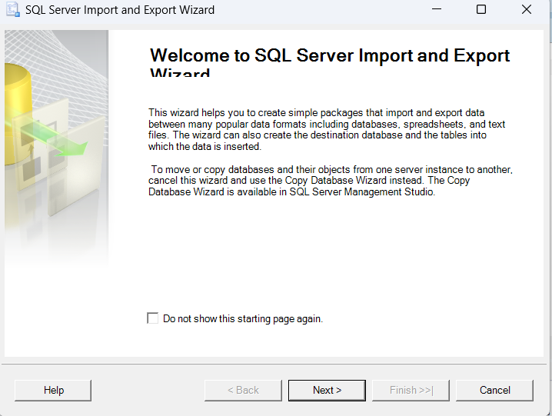
Image – 7(SQL server import and export Wizard)
Then click Next-> Data Source
For me the Data Source is Microsoft Excel then it will ask Excel file path copy then Click the 'Browse' button to select the path to the Excel file you want to import
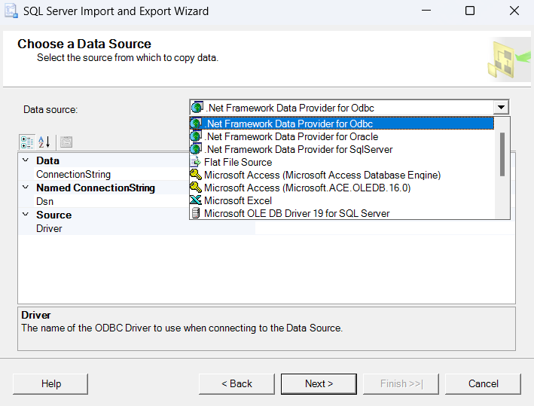
Image – 8(Data source)
On the 'Choose a Destination' screen, select destination database:
Select the 'Server name', Authentication (typically your SQL username & password) and select a Database as destination. Click Next.
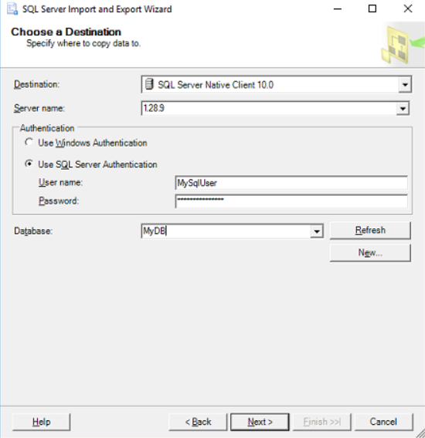
Image – 9(Choose a destination)
Select source table choose the worksheet then click Next -> click Finish
We have successfully imported the data in SQL
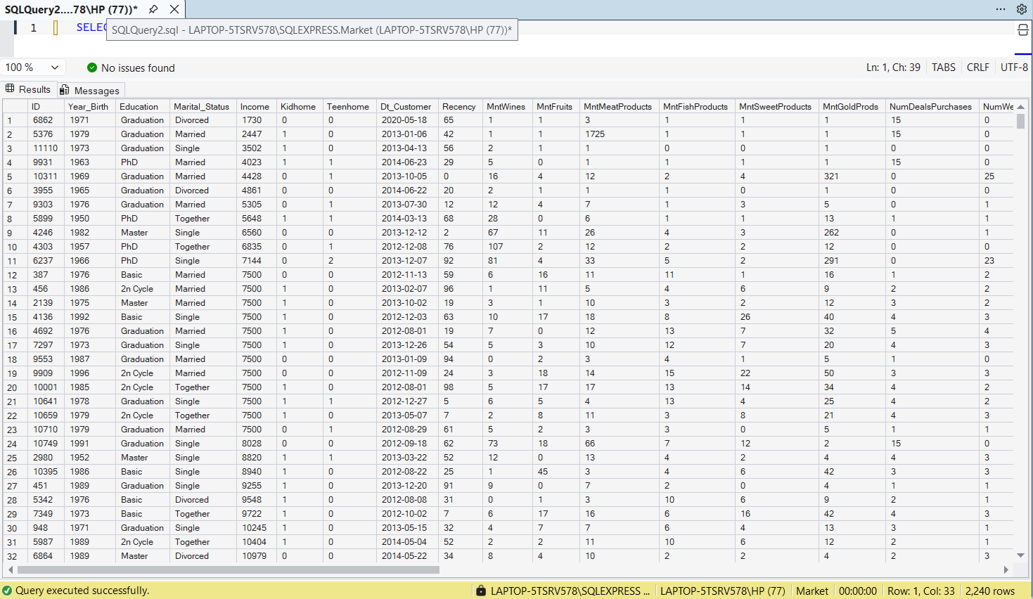
Image – 10(Checking all data successfully imported)
USING QUERY:-
SELECT * FROM marketing_campaign_data
STEP 2: DATA CLEANING
Data Cleaning is one of the most important task in data analysis. It is where about 60-80% time is taken.
Data cleaning is the process of preparing raw data by correcting errors, handling missing values and removing inconsistencies. It is to ensure the data is accurate and suitable for analysis
There can be following data issue:-
1. Duplicate rows:- Two rows can have same values this can lead to incorrect counts and metrics
We can handle them in sql by these methods:-
ROW_NUMBER() :- It is a function in SQL it is a window function that assigns a unique sequential integer to each row without leaving ties.
DISTINCT :- It is to remove duplicate rows in data.
GROUP BY :- It is to remove duplicate rows in data.
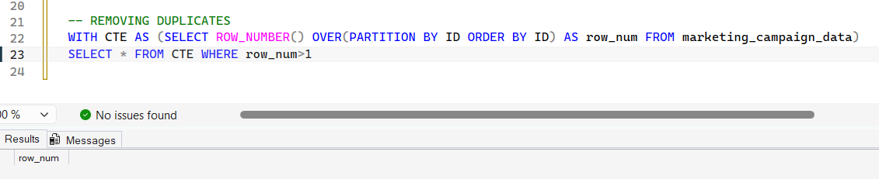
Image – 11(Removing duplicates)
NOTE:- THIS SHOWS THAT THERE ARE NO DUPLICATE ROWS IN THE DATA

2. Inconsistent formatting:- Mixed date formats, Casing differences , irregular spacing we can handle them by:-
MIXED DATE FORMATS:- We can use CAST()
CASING DIFFERENCES:- We can use UPPER() and LOWER()
IRREGULAR SPACING:- We can use TRIM()
NOTE:- THERE ARE NO LEADING SPACES IN THE DATA AND THE DATE IS IN THE CORRECT FORMAT

3. Missing or null values:- Broken calculations , misleading averages we can handle them by:-
COALESCE() :- It is used to handle the null values we can use any data type here.
Conditional Imputation :- Using CASE WHEN we can handle the missing and null values.
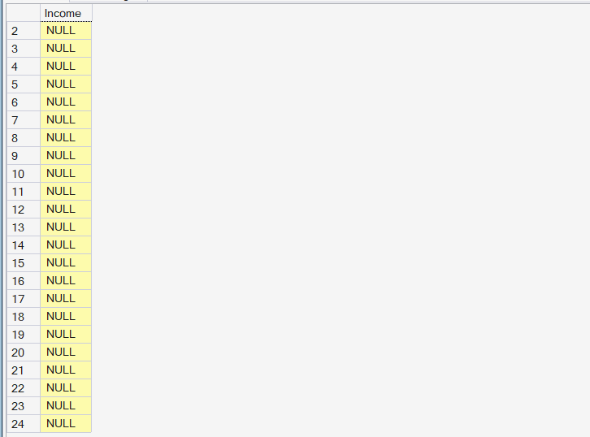
Image – 12(Checking income null values)
Now we can handle them by using COALESCE()
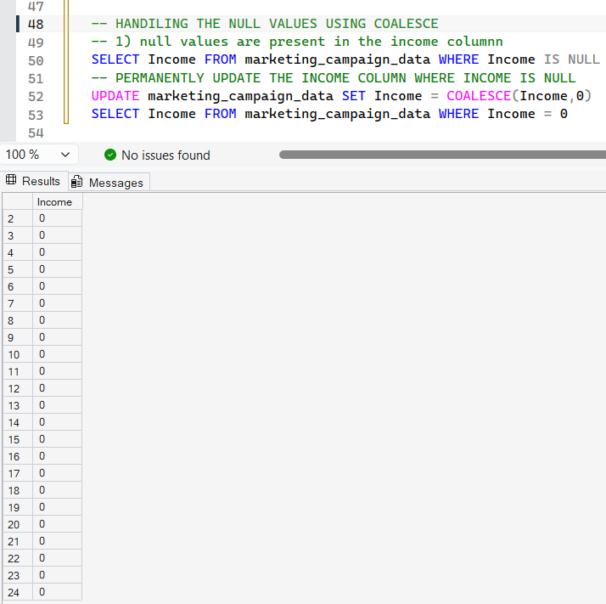
Image – 13(Handling the income null values)
4. Data type mismatches:- Query errors , Incorrect sorting we can handle them by:-
CAST() :- The CAST function is a tool in SQL that is used to explicitly convert a value or expression from one data type to another.
CONVERT() :- The CONVERT function is used to transform an expression from one data type to another. It is used in SQL server and MySQL.
5. Trailing spaces and hidden characters:- Falling joins and grouping it can be handle by:-
TRIM() :- It removes spaces ( or specified characters) from both ends of the string.
REPLACE() :- The REPLACE() function searches a string for a specific substring and replaces all its occurences with a new substring.
SYNTAX:-
REPLACE(string_expression, search_string, replacement_string)

6. Inconsistent categorical values:- eg:- US , U.S. OR United States we can handle all of them by using UPDATE or CASE WHEN.
We don’t have any Inconsistent categorical values in the country column but we have to update the following columns:-
- We know that Martial Status can be divorced, married, single and widow but according to data
- We can merge alone as single because alone is somewhat similar to single and it contains less data.
- Together can also be classified as that they can be married or they are not married but only on living basis so we can categorize them as domestic partners.
- Update the 2n cycle by Associate degree.
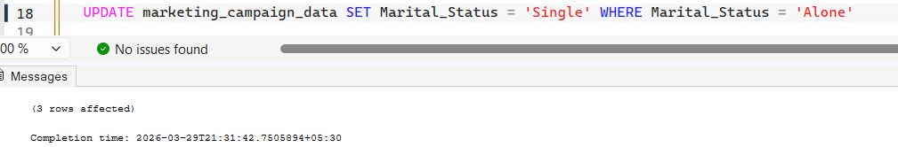
Image – 14(update alone to single)
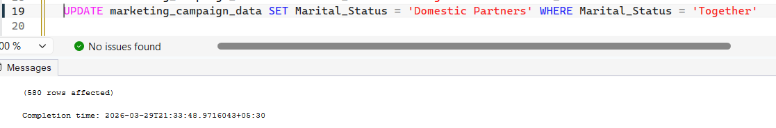
Image -15(update together to domestic partners)
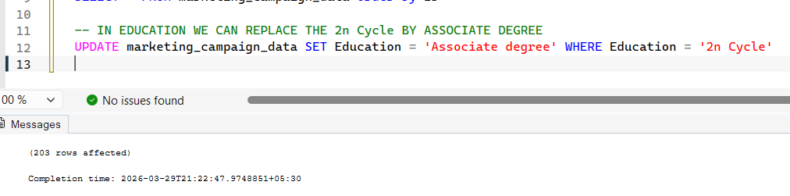
Image – 16(update 2ncycle to associate degree)

Deleting the columns such as YOLO and Absurd
Image – 17(deleting Yolo and absurd)

STEP 3: DATA PREPROCESSING
Based on the Impressions, Clicks, Conversions and Cost The derived values such as CTR , CPC , and Conversion Rate are calculated and included in the dashboard.
CTR (Click Through Rate):- Is a digital marketing metric that measures the percentage of people who click a link after seeing it. Higher CTR indicates the better ad and customer engagement.
CTR = Clicks / Impressions (views) * 100
CPC(Cost Per Click):- IIs a digital advertising model when a advisers pay a platform when a user clicks on an ad, basically it means cost for each click.
CPC = Total Cost for Cost/ total Number of Clicks
Conversion Rate:- It is the practice of optimizing websites it basically means the percentage of clicks that become customers.
Conversion Rate = Total conversions / Total Clicks * 100
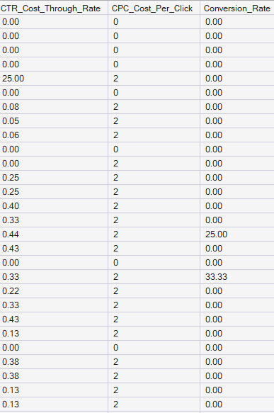
Image – 18(CTR,CPC, AND CONVERSION RATE)
Changing the columns from Varchar to Decimal
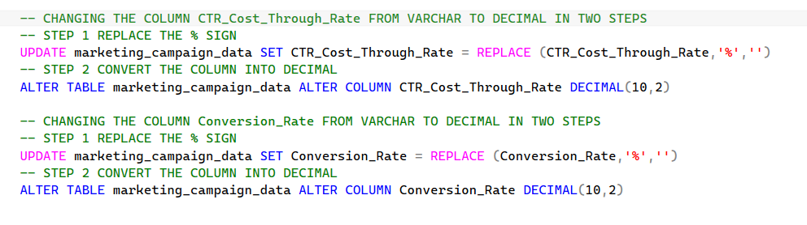
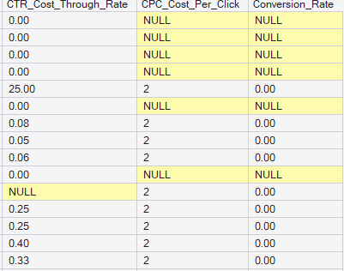
Image – 19(Changing varchar to decimal)
NOW HANDLING THE NULL VALUES IN CTR , CPC AND CONVERSION RATE COLUMNS.
Checking the null values in CTR column
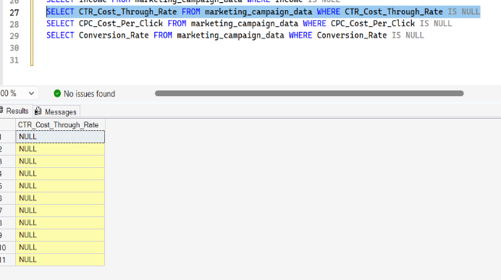
Image – 20(Checking null values in CTR column)
Checking the null values in CPC column
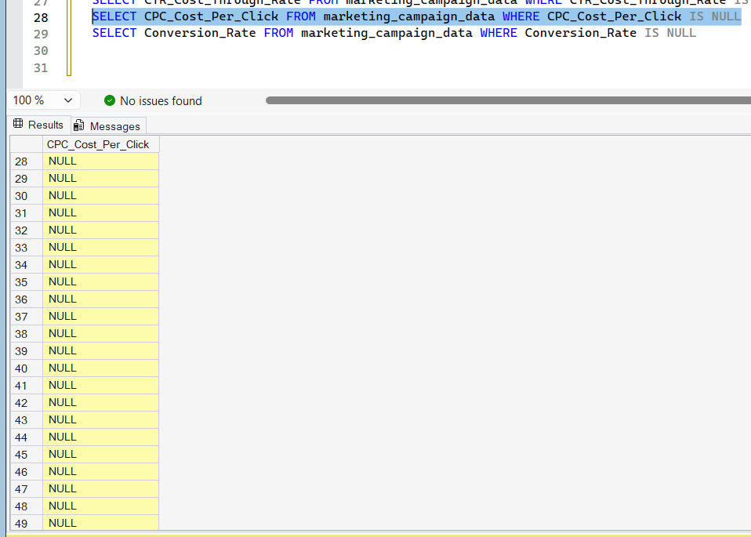
Image – 21(Checking null values in CPC column)
Checking the null values in Conversion Rate column
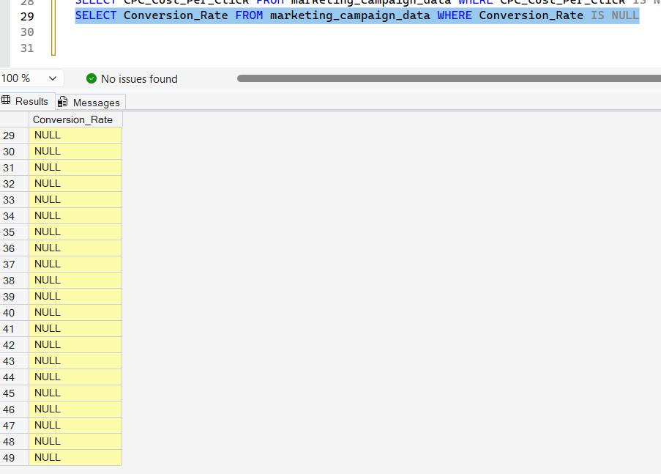
Image – 22(Checking null values in Conversion Rate column)
NOW HANDLING THE NULL VALUES:-
Handling the null values in CTR column:-
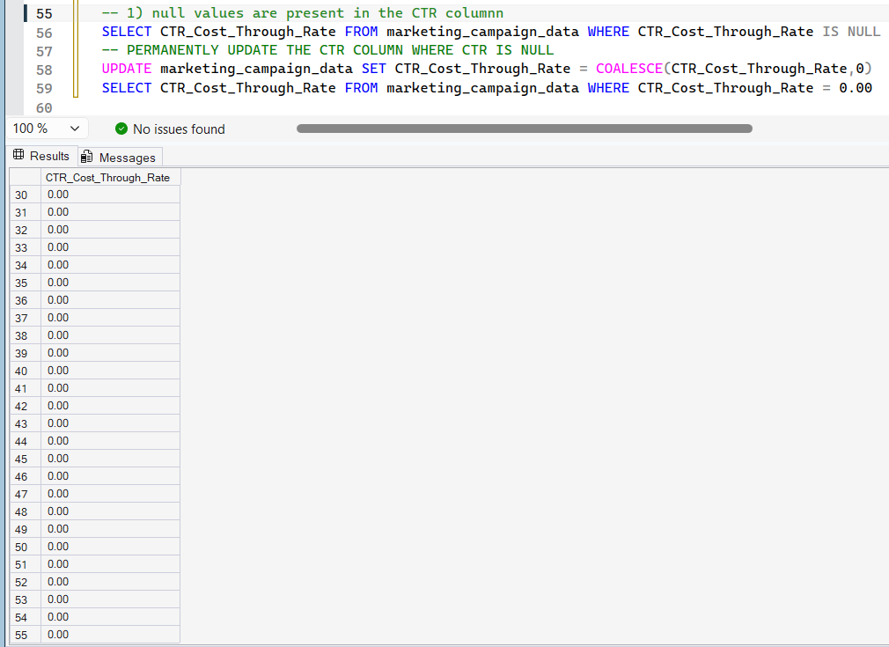
Image – 23(Handling null values in CTR column)
Handling the null values in CPC column:-
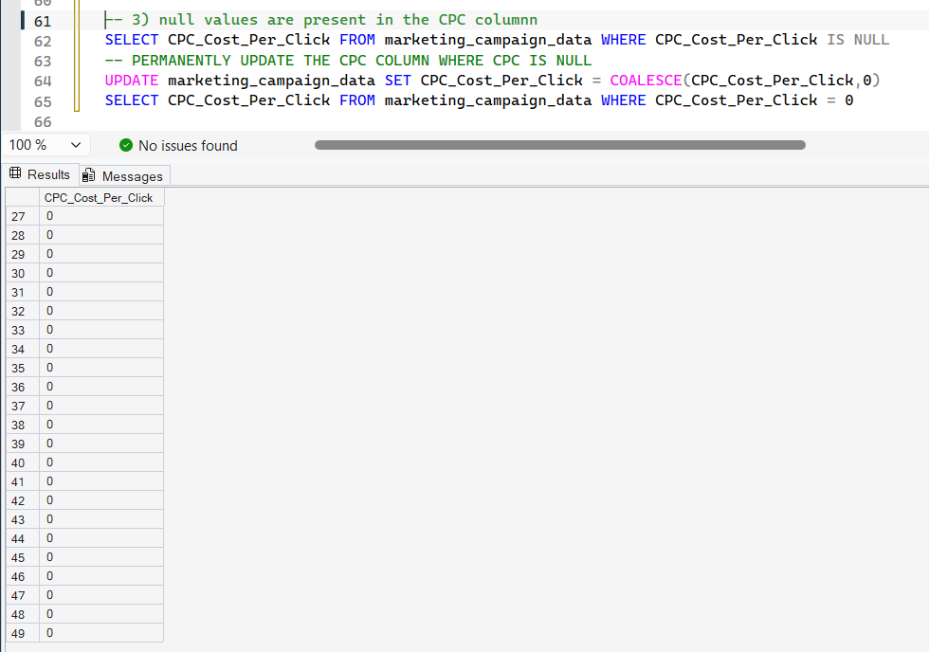
Image – 24(Handling null values in CPC column)
Handling the null values in Conversion Rate column:-
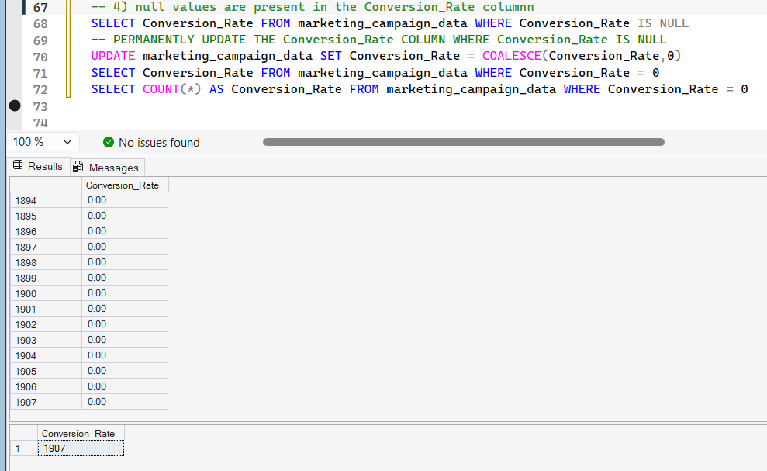
Image – 25(Handling null values in Conversion Rate column)

Conclusion:- The preprocessing plays an important role in marketing analysis Proper data cleaning ensures accuracy. The use of SOL for data transformation improves efficiency and scalability.
The dataset is now fully cleaned, transformed, and ready for advanced analysis and dashboard creation.

EXCEL WORKBOOK CLEAN DATA:-
clean data.xlsx

